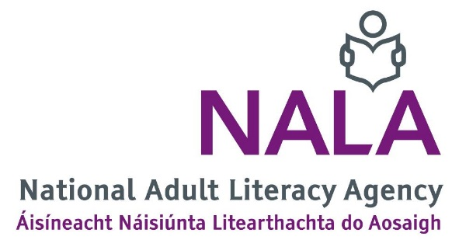

Job application form for NALA Digital Marketing, Information and Content Officer

Notes
- Type and email this job application form to recruitment@nala.ie by 5 pm Friday 21 January 2022.
- Use a clear font such as Arial or Verdana, font size 12 with 1.5 line spacing.
- Keep to the maximum word count in each section.
- Section 1 (Personal details) and section 2 (References) must be completed.
- For section 3 (Relevant qualifications) and section 4 (Relevant work experience) begin at the most recent date. You can add more fields to these sections if you need.
- Section 3 to 12 will be marked.
- Applicants with the highest marks may be asked to do an online assessment week beginning 31 January 2022, and or attend an interview the week beginning 7 February 2022.
- If you have any questions email recruitment@nala.ie or call 01 412 7905.

Office use only
Application number | Date received

- Personal details
Name
Telephone
Email
Address

- References
Provide two work references with a contact email and phone number. We will let you know if we are going to contact your referees.

- Relevant qualifications
Name of qualification, for example Masters, Degree, Diploma, Leaving Certificate | Name of university, college or school | Grade awarded | Year obtained

- Relevant work experience
Your job title
Name and address of your employer, company or organisation
Duration of employment, for example from March 2014 to present
Describe your main duties and responsibilities | (150 words maximum)

Your job title
Name and address of your employer, company or organisation
Duration of employment, for example from March 2014 to present
Describe your main duties and responsibilities | (150 words maximum in this section)

- Digital marketing experience
Provide an example of a digital marketing strategy that you developed and delivered. What tactics did you use? What impact did your strategy have and how did you measure the impact?
(200 words maximum in this section)

- Online publishing experience
Provide evidence of your experience publishing content online, for example publishing content on websites, social media platforms, e-zines or blogs. Who have you published for and what platforms or systems have you used?
(100 words maximum in this section)

- Website management
Provide evidence of your experience of website management, including actions taken
to increase performance, user experience and compliance with GDPR. What tactics
did you use? What impact did your work have?
(200 words maximum in this section)

- Social media communities
Provide evidence of when you have managed and facilitated social media communities or cultivated key relationships across social media platforms. How did you achieve this and what impact did it have?
(200 words maximum in this section)

- Paid-for online promotion
Describe how and when you have used paid-for online advertising to promote an issue, product or event. What was your budget? What paid-for products and platforms did you use? How did you evidence the impact of paid promotion?
(200 words maximum in this section)

- Evaluating your work – insights and trends
Provide an example of when you identified trends and insights, and optimised spend and performance for a digital marketing campaign based on learned insights. Describe the steps you took, the changes you made and the results of your work.
Provide examples of how you evaluated your digital marketing spend.
(200 words maximum in this section)

- Communication and interpersonal skills
Provide evidence of your communication and interpersonal skills. For example, working with other staff, clients, stakeholders, sponsors or third-party agencies to achieve a communications objective.
(200 words maximum in this section)

- Any other information
Provide any other information you think is relevant to your application for this job.
(200 words maximum in this section)

