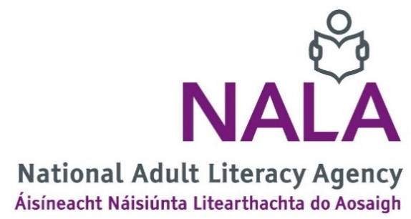

Application form: Learn With NALA Support Officer
Notes
- Complete this job application form and email, with a CV and Cover Letter, to recruitment@nala.ie by 5pm Friday 2 December 2022
- Use a clear font
- Keep to the maximum word count in each section.
- Section 1 (Personal details) and section 2 (References) must be completed.
- For section 3 (Relevant qualifications) and section 4 (Relevant work experience) begin at the most recent date. You can add more fields to these sections if you need to.
- Section 3 to 9 will be marked.
- Applicants with the highest marks will be asked to attend an interview the week beginning 12 December 2022.
- If you have any questions email recruitment@nala.ie or call 01 412 7900.

Office use only
Application number | Date received

- Personal details
Name
Telephone
Email
Address

- References
Provide two work references with a contact email and phone number. We will let you know if we are going to contact your referees.

- Relevant qualifications
Name of qualification, for example Masters, Degree, Diploma, Leaving Certificate | Name of university, college or school | Grade awarded | Year obtained

- Relevant work experience
Your job title
Name and address of your employer, company or organisation
Duration of employment, for example from March 2018 to present
Describe your main duties and responsibilities | (150 words maximum)

Your job title
Name and address of your employer, company or organisation
Duration of employment, for example from March 2018 to present
Describe your main duties and responsibilities | (150 words maximum in this section)

- 3 years experience
Provide evidence of 3 years relevant experience
(300 words maximum in this section)

- Technical skills
Provide evidence of your technical skills (For example: proficiency in MS office, Salesforce or other CRM systems, Brightspace of other online Learning Systems)
(200 words maximum in this section)

- Organisational skills

Provide evidence of your organisation skills (For example: The capacity to manage a diverse work load, be self-motivated and to prioritise responsibilities)
(200 words maximum in this section)

- Communication and interpersonal skills
Provide evidence of your communication and interpersonal skills. (For example working with other staff, clients, stakeholders)
(200 words maximum in this section)

- Any other information
Provide any other information you think is relevant to your application for this job.
(200 words maximum in this section)

