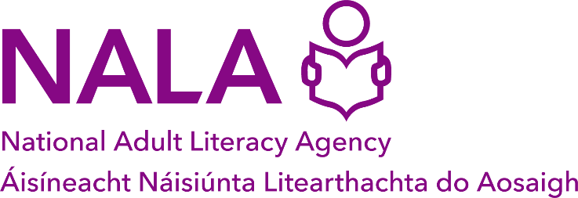

Application form: Learn with NALA Coordinator
Notes
- Complete this job application form and email, with a CV and Cover Letter, to recruitment@nala.ie by 5pm Friday 8 April 2024
- Use a clear font
- Keep to the maximum word count in each section
- Section 1 (Personal details) and section 2 (References) must be completed
- For section 3 (Relevant qualifications) and section 4 (Relevant work experience) begin at the most recent date. You can add more fields to these sections if you need to
- Section 3 to 12 will be marked
- Applicants with the highest marks will be asked to attend an interview on 23 or 24 April 2024
- If you have any questions email recruitment@nala.ie or call 01 412 7900.

Office use only
Application number | Date received

- Personal details
Name
Telephone
Email
Address

- References
Provide two work references with a contact email and phone number. We will let you know if we are going to contact your referees.

- Relevant qualifications
Name of qualification, for example Masters, Degree, Diploma, Leaving Certificate | Name of university, college or school | Grade awarded | Year obtained

- Relevant work experience
Your job title
Name and address of your employer, company or organisation
Duration of employment, for example from March 2018 to present
Describe your main duties and responsibilities | (150 words maximum)

Your job title
Name and address of your employer, company or organisation
Duration of employment, for example from March 2018 to present
Describe your main duties and responsibilities | (150 words maximum in this section)

Your job title
Name and address of your employer, company or organisation
Duration of employment, for example from March 2018 to present
Describe your main duties and responsibilities | (150 words maximum in this section)

Your job title
Name and address of your employer, company or organisation
Duration of employment, for example from March 2018 to present
Describe your main duties and responsibilities | (150 words maximum in this section)

- 5 years’ experience
Provide evidence of 5 years relevant experience
(300 words maximum in this section)

- Experience managing and leading a team
Provide evidence of your skills in leading, managing and developing a team.
(200 words maximum in this section)

- Adult literacy skills
Provide evidence of your skills and experience with tutoring and supporting adults with unmet literacy, numeracy and digital literacy needs.
(200 words maximum in this section)

- Experience developing and implementing quality assurance policies and procedures
Provide evidence of your skills in leading, managing and developing a team.
(200 words maximum in this section)

- Delivering technology enhanced learning / blended learning
Provide evidence of your skills in coordinating and delivering technology enhanced learning through a learning management system such as Brightspace / Canvas / Moodle and / or your skills in delivering blended / distance learning.
(200 words maximum in this section)

- Organisational and Information Technology (IT) skills

Provide evidence of your skills in organisation and IT skills particularly with Mircrosoft Office, Sharepoint, Salesforce or other Customer Relationship Management (CRM) systems.
(200 words maximum in this section)

- Communication and interpersonal skills
Provide evidence of your collaboration, communication and interpersonal skills. (For example working with vulnerable groups, within a team, or with clients)
(200 words maximum in this section)

- Any other information
Provide any other information you think is relevant to your application for this job.
(200 words maximum in this section)

